 |  | 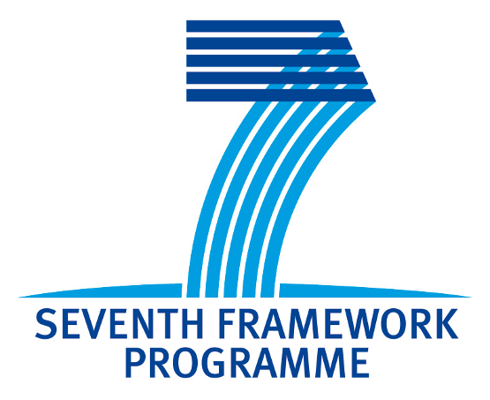 | 
University of Zagreb | Faculty of Textile Technology | 7th Framework Programme | FP7-REGPOT-2008-1:T-Pot |   Croatian Association of Textile Engineers  CH05/0461

Invitation to science – professional workshop
PROTECTIVE PROPERTIES OF NATURAL DYESTUFF

Organised in cooperation
Textile Science Research Centre (TSRC)
University of Zagreb Faculty of Textile Technology
In a scope of a project FP7-REGPOT-2008-1-229801:T–Pot

Association "Gačanka"
And
Croatian Association of Textile Engineers (HIST)

18th April, 2011, Otočac, 11a.m.

Scientific – professional cooperation is initiated among Department of Textile Chemistry and Ecology of Faculty of Textile Technology University of Zagreb, Textile Science Research Centre (financed within the European project FP7- REGPOT-2008-1: T–Pot project) and Centre for Traditional Crafts of association Gačanka from Otočac, under the patronage of Croatian Association of Textile Engineers.

After the workshop with invited lectures, the visit of mills on the river Gacka is organised. The mills are part of the Croatian national heritage.

Program of scientific – professional workshop

18th April, 2011, Association "Gačanka"; Ante Starčevića 3, Otočac, 11 a.m.

Dragica Rogić  President of the association "Gačanka" | Presentation of the project "Centre for Traditional Crafts"
Sandra Bischof Vukušić  Coordinator of a project  FP7-REGPOT-2008-1-229801: T–Pot | Presentation of a project "T-Pot" and Textile Science Research Centre
Đurđica Parac – Osterman  Head of the Department of Textile Chemistry and Ecology of Faculty of Textile Technology, University of Zagreb | The Importance of Natural Dyestuff for Original Croatian Brands
Tanja Pušić  Faculty of Textile Technology, University of Zagreb  Department for Textile Chemistry and Ecology | Alternative Agents for Washing
Željko Knezić  Faculty of Textile Technology, University of Zagreb  Department for Textile Design and Management | Manually Weaving – Part of the Croatian Ethno Heritage
 | Discussion on further cooperation



