 |  | 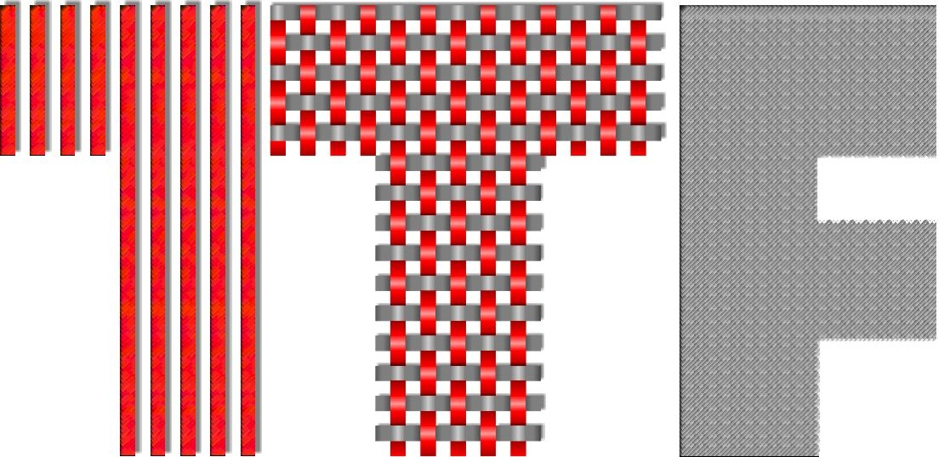
http://www.unizg.hr | http://www.ts-rc.eu | http://www.ttf.unizg.hr

EVALUATION CRITERIA FOR SCIENCE CATEGORY

for papers submitted at the Textile Sceince Research Centre 2016 Award Competition

 | CRITERIA | Maximum scores | Scores
1. | CATEGORY:  Can paper be categorised as original? | 10
3. | POTENTIAL:  Does the paper have potential for the publication in WoS journals  a) as submited, b) with minor revision, c) with major revison | 30
3. | STRATEGIC GOALS:  Does the paper cover strategic goals of Horizon 2020 and/or The Textile Flagships of European Technological Platform for the Future of Textile and Clothing | 10
4. | INOVATIVE CHARACTER:  Has the paper significant innovativeness within national or international borders? | 30
5. | APPLICABILITY:  To what extent can research finding be implemented in practice? | 20
 | TOTAL: | 100

EVALUATION CRITERIA FOR ART CATEGORY

for papers submitted at the Textile Sceince Research Centre 2016 Award Competition

 | CRITERIA | Maximum scores | Scores
1. | WRITING AND ELABORATION OF THE TEXT:  Can paper be categorised as original? | 10
2. | INNOVATION | 30
3. | CREATIVITY | 10
4. | PORTFOLIO | 30
5. | REALIZATION AND PRESENATION | 20
 | TOTAL: | 100

