 |  | 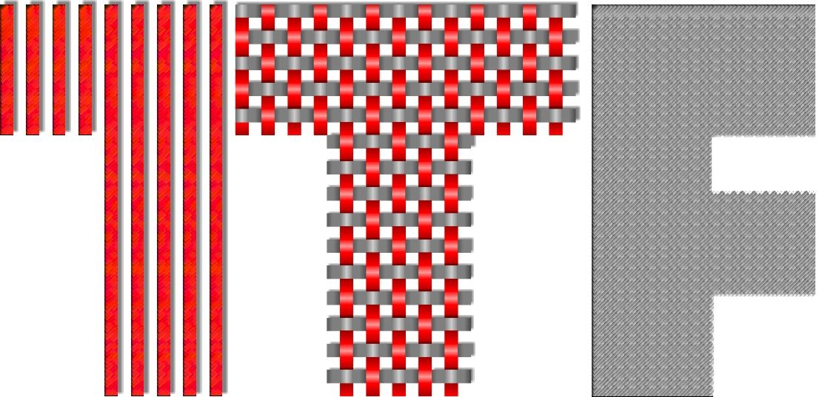
http://www.unizg.hr | http://www.ts-rc.eu | http://www.ttf.unizg.hr

Award of Textile-Science Research Centre (TSRC) for 2016

Award in the category I is assigned to the PhD student Zorana Kovačević, BSc for the most sucessfull scientific work in the field of textiles:

FLAME RETARDANT TEXTILE REINFORCED NANOBIOCOMPOSITES

Biocomposite production has started due to increased demand for use of sustainable and biodegradable natural materials and therefore reduction of environmental pollution.. Production of biocomposites, consisting of a biopolymer matrix and natural bast fibers like flax, hemp, ramie or Spartim junceum L., is significantly increased in recent years. Biocomposites have a various applications and one of them is in the area of protective textiles, whose main task is to protect people from injuries caused by the unpredictable situations. Modification of Spartium junceum L. fibres, with the aim of fire protection, has been studied in this paper. Nanoclay (montmorillonite-MMT) was used in the role of flame retardant (FR) nanofiller and citric acid (CA) in the role of environmentally friendly curing agent. Fibre properties were investigated using following thermal techniques: thermogravimetric analysis (TGA), microscale combustion calorimetry (MCC) and differential scanning calorimetry (DSC). Results revealed that fibres treated with MMT poses enhanced thermal stability and resistance to fire, compared with a neat Polylactic acid (PLA) polymer or biocomposite reinforced with reference (untreated) fibres.

Keywords: flame retardancy, natural fibres, nanofillers, nanoclay, nanobiocomposites, Spartium junceum L.


Zorana Kovačević has been employed at the University of Zagreb Faculty of Textile Technology since her undergraduate study (2009) till today. Positions, she has held during this time, were asistant for the EU and national projects (FP7– REGPOT-2008-1-229801: T-Pot and Revitalisation of textile production of Spartium juncem L. – Development of autochthon Croatian product: From weed to fabric), associate – specialist for SEM, FTIR, TG, and since 2013th participating in the performance of practical training at the graduate and undergraduate study. Since 2010/2011 Zorana Kovačević has been enrolled in PhD study at the University of Zagreb Faculty of Textile Technology. She published 1 University book, 1 chapter in scientific book, 2 original scientific papers in tertiary publications, 2 original scientific papers in secondary publications and 16 papers arising from participation in recognized national and international conferences and summer schools.

