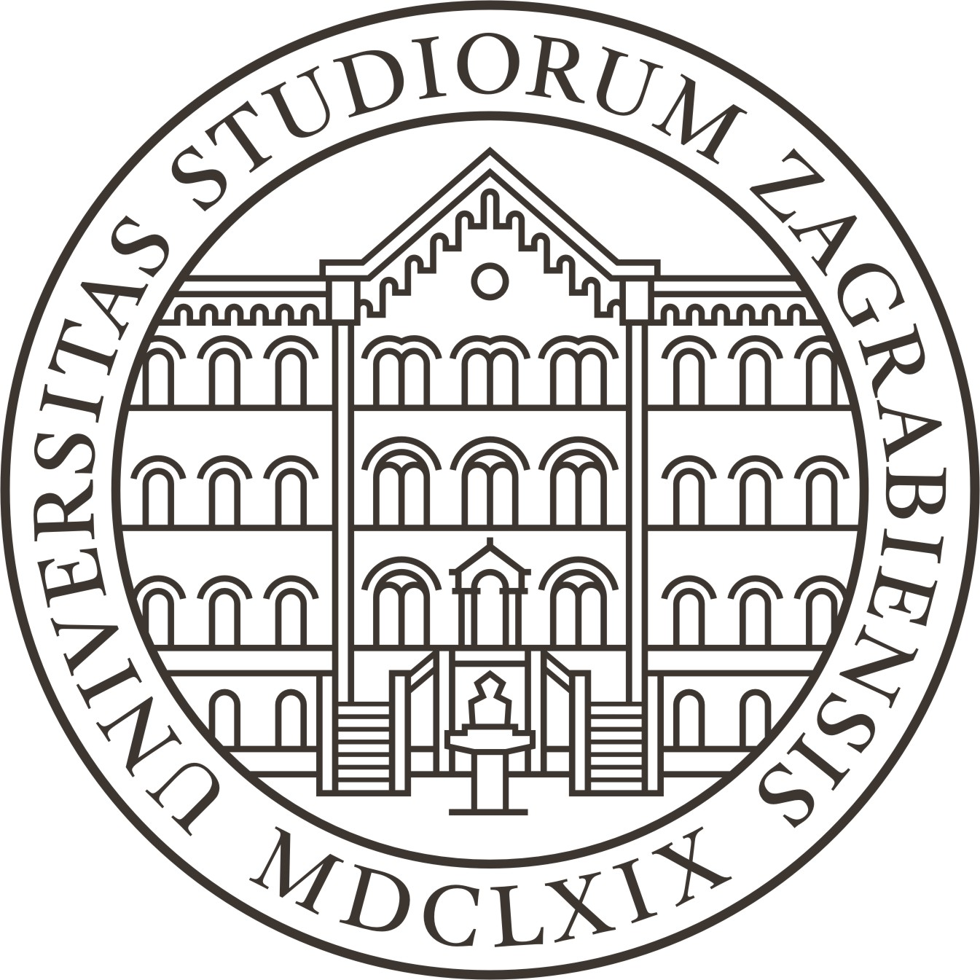 |  | 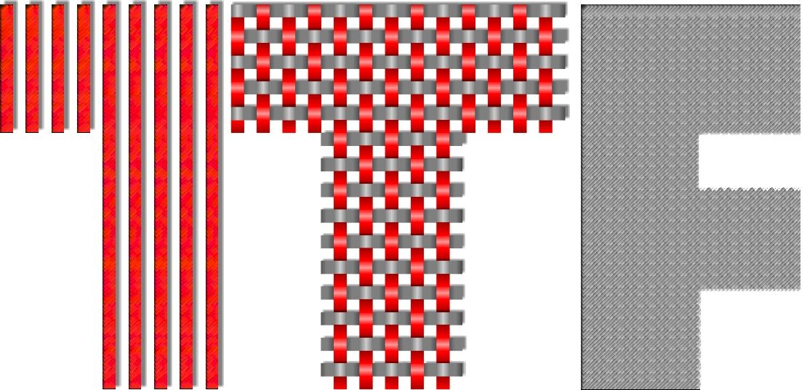
http://www.unizg.hr | http://www.ts-rc.eu | http://www.ttf.unizg.hr

Textile-Science Research Centre (TSRC) announces the following:

competition

for the award for the most successful scientific or artistic research work in the field of textiles

The competition is divided into two separate categories:

Category I: for young scientists/artists (doctoral or postdoctoral students) of the University of Zagreb Faculty Of Textile Technology (age limit is 35)
Category II: for students of undergraduate/graduate studies of University of Zagreb, Faculty of Textile Technology.

One award in each category will be granted at Faculty Day in January 2018.

Submissions for entry forms should be sent until September 1st 2018 to: tpusic@ttf.hr and info@ts-rc.eu. Three committee members will perform the final ranking within each category due to the Criteria list TSRC_Award_Critera_2018.doc.

The application must be enclosed with CV, list of publications and name of the journal where the author wishes to submit the paper. Papers should be written in English, on maximal ten pages according attached form TSRC_Template.doc.

Zagreb, May 4th 2018

Prof. Tanja Pušić, PhD
Head of TSRC

